**Green Data Science Individual Report**

1. **Objective and Assumptions**

To achieve the goals of the Paris Climate Agreement and to comply with the concept of ESG investment, this exercise aims to find a portfolio for the optimal expected return with the target ESG performance.

This exercise allows no short sell, and the portfolio alignment is conducted based on 100 companies randomly selected from S&P 500.

1. **Choice of the carbon metric**

One of the most critical ESG issues is greenwashing. Greenwashing is considered an unsubstantiated claim to misguide customers and the general public into believing that a company is investing in ESG and has a brilliant ESG performance. It incentivises companies to disclose information that only benefits themselves.

In this exercise, ESG combined score is used as the carbon metric. ESG score is only based on self-reported information, which could be modified by companies themselves. But ESG Combined Score is an overall company score based on the reported information in the environmental, social and corporate governance pillars (ESG Score) with an ESG Controversies overlay. It magnifies the impact of significant controversies on the overall ESG scoring and avoids being abused by companies. Also, Refinitiv calculated and published its ESG combined score on the same standard for all firms. It is well comparable and easy to access.

1. **Optimizations based on the Market Capitalization-Weighted Index**
   1. **Market Capitalization-Weighted Index**

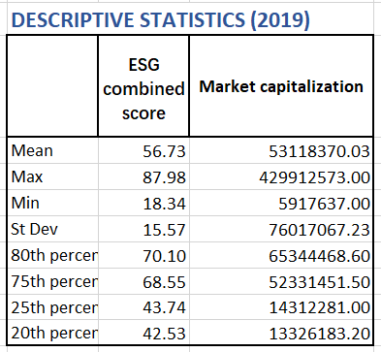

The portfolio includes 100 random stocks from the S&P 500 Index and is taken as the benchmark for optimizations. From the table, the ESG combined score averaged 56.73, ranging from 18.34 to 87.98. And the annualized expected return is 14.46%[1].

* 1. **Optimization with decarbonized constraint**

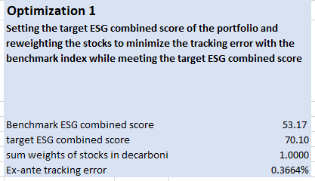

The target ESG combined score is 70.10, the 80th percentile of the total ESG combined score. The optimization is set to reweight the stocks to minimize the tracking error[2] while meeting the target ESG combined score.

The optimization is solved with a minimum tracking error of 0.3664%[3]. The new portfolio has an annualized return of 15.62% and a standard deviation of 16.76%[4]. The return slightly increased while the deviation slightly decreased compared to the benchmark portfolio.

* 1. **Optimization with decarbonized and industry constraints**

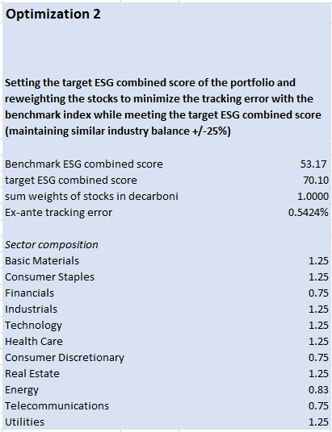

Based on the decarbonized constraint in optimization 1, an industry constraint of maintaining an industry balance of +/-25% is added to optimization 2.

The optimization is finally solved by finding a portfolio with a minimum tracking error of 0.5424%[5]. Compared to the former optimization, it achieved the target ESG combined score with a price of decreasing annualized return from 15.62% to 15.05%. And with the decrease in the annualized return, the deviation falls from 16.76% to 16.68%[6].

* 1. **Optimization with a target tracking error**

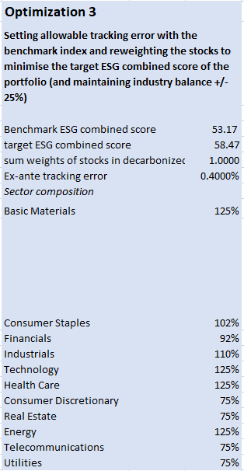

Optimization 3 is set to minimize the target ESG combined score while meeting the target tracking error and the industry constraint. The target tracking error is 0.4%[7].

The solver finally achieved an ESG combined score of 58.47[8], increasing from the benchmark of 53.17. To achieve this, the annualized return and deviation fall to 14.41% and 16.75%[9], both below the benchmark.

1. **Optimizations based on MPT Optimal Portfolio**
   1. **MPT Optimal portfolio**

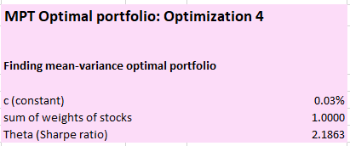

The modern portfolio theory (MPT) is a method that can help investors achieve the best result by constructing diversified portfolios that maximize the return without unacceptable levels of risk.

The first MPT optimization has no decarbonized or industry constraints and aims to find the mean-variance optimal portfolio with a maximum Sharpe ratio.

Assume a risk-free rate of 0.03%. The MPT optimal portfolio achieves a Sharpe ratio of 2.1863 and an annualized return of 28.57%. The standard deviation reaches a low point of 13.05%[10].

* 1. **MPT Decarbonized portfolio**

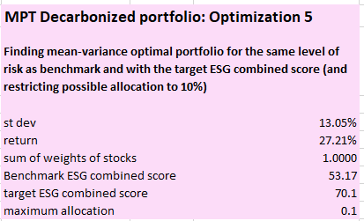

This optimization aims to find an optimal portfolio for the same risk level as the benchmark and with the target ESG combined score of 13.05%[11]. Restrict the maximum allocation in one company to 10%.

The annualized return of the MPT Decarbonized portfolio reaches 27.21%[12].

* 1. **MPT Industry Decarbonized portfolio**

Based on the MPT Decarbonized optimization, the MPT Industry Decarbonized optimization adds an industry constraint of maintaining an industry balance of +/-25% and removes the maximum allocation constraint.

With the industry constraint, the return of the MPT Industry Decarbonized portfolio decreases to 25.17%, while the deviation remains unchanged.

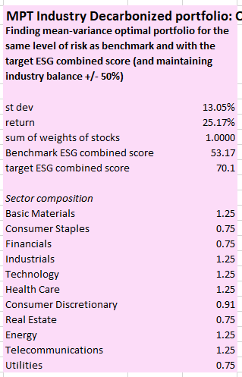

1. **Industry Composition**

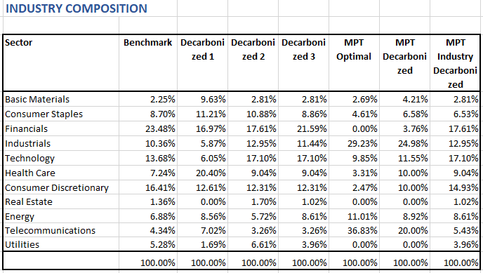

The portfolios mainly consist of companies from the financial, industrial and technology sectors.

1. **Sector Analysis**

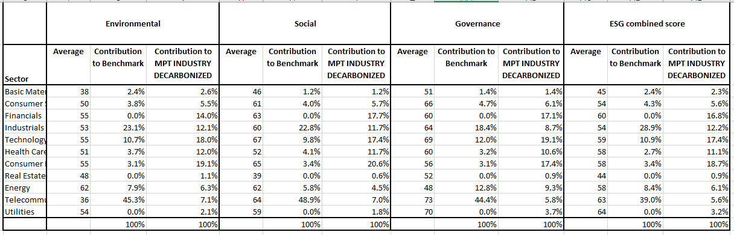

Before decarbonization, the telecommunication and industrial sectors comprise a large portion of the MPT (benchmark) portfolio. After decarbonized optimization, the proportion has decreased to less than 10%. In the meantime, the proportion of financial and technology sectors has increased significantly.

1. **Limitations**

ESG is a new concept with less relevant data and always missing. And data from only one third-party rating agency cannot entirely avoid greenwashing.

1. **Conclusion**

The MPT portfolio represents the best portfolio the risk-averse investors can get along the efficient frontier. Adding any decarbonized or industry constraint will change the optimal weights and, therefore, decrease the return.

The practical implication of decarbonized optimization is to comply with the ESG concept while maintaining the loss caused by decarbonization within an acceptable tolerance.

**REFERENCE**

<https://sciencebasedtargets.org/blog/portfolio-alignment-financial-institutions>

<https://www.investopedia.com/terms/m/modernportfoliotheory.asp>

1. Annualized expected return of the benchmark portfolio is calculated in the sheet labelled **RETURN**
2. The covariance matrix needed in calculating the tracking error is in the sheet labelled **covariance matrix**
3. See optimization 1 solver in the workbook
4. See the **Decarbonized 1** column of optimization set up table in the sheet labelled **PORTFOLIO**
5. See optimization 2 solver in the workbook
6. See the **Decarbonized 2** column of optimization set up table in the sheet labelled **PORTFOLIO**
7. A target tracking error between tracking errors achieved in optimization 1 and 2 is chosen
8. See optimization 3 solver in the workbook
9. See the **Decarbonized 3** column of optimization set up table in the sheet labelled **PORTFOLIO**
10. See the **MPT Optimal** column of optimization set up table in the sheet labelled **PORTFOLIO**
11. Standard deviation of the MPT portfolio
12. See the **MPT Decarbonized** column of optimization set up table in the sheet labelled **PORTFOLIO**